The terraform init command is used to initialize a working directory containing Terraform configuration files. This is the first command that should be run after writing a new Terraform configuration or cloning an existing one from version control.

Here is a brief overview of what terraform init does:

1. **Initializes the backend**: Configures the backend where Terraform state is stored.
2. **Downloads provider plugins**: Fetches the provider plugins required by the configuration.
3. **Sets up the workspace**: Prepares the environment for other Terraform commands.

Case1: Running terraform command without any configuration:

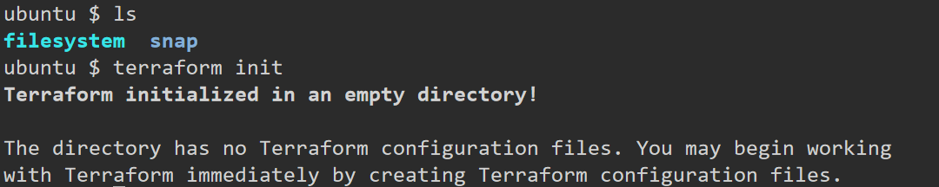

Case2: Running terraform command with empty configuration

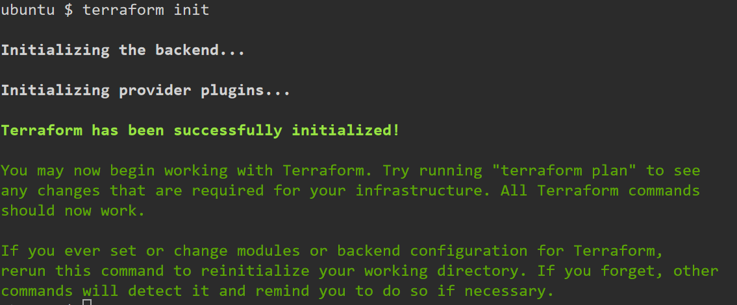

As we have not specified any configuration, terraform didn’t downloaded plugin

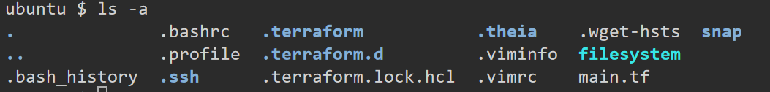



What is Terraform provider?

A Terraform provider is a plugin that allows Terraform to interact with various external systems and services. Providers define resources and data sources for those services, enabling Terraform to manage infrastructure on different platforms.

Running terraform init command

